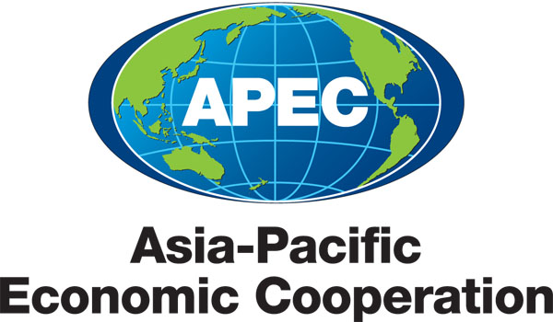
________________________________________________________________________

Information Privacy Individual Action Plan

Explanatory Notes

1. At the 16th APEC Ministerial Meeting at Santiago, Chile in November, 2004, the APEC Privacy Framework (“the Framework”) was adopted.

2. Paragraph 39 within Part IV, Section A, VI, of the Framework describes a Mechanism for Reporting Domestic Implementation of the Framework as follows:

39. Member economies should make known to APEC domestic implementation of the Framework through the completion of and periodic updates to the Individual Action Plan (IAP) on Information Privacy.

- An IAP will improve transparency of data protection framework of an economy which in effect will enable other economies to be informed of the relevant stage that an economy has reached. That matches with the overall objective of the Framework, i.e. to encourage the development of common effective privacy protections and ensure the free flow of information in the region.

- APEC Member Economies should endeavor to give effect to the Framework and secure privacy protections for individuals by methods which are considered most suitable to Member Economies, including legislative, administrative, industry self-regulatory or a combination of these methods.

- As stated in paragraph 32 of the Framework, it may be appropriate for individual economies to determine that different APEC Privacy principles may call for different means of implementation. Whatever approach is adopted in a particular circumstance, the overall goal should be to develop compatibility of approaches in privacy protections in the APEC region that is respectful of requirements of individual Member Economies.

- As stated in paragraph 34 of the Framework, discussions with domestic law enforcement, security, public health, and other agencies are important to identify ways to strengthen privacy without creating obstacles to national security, public safety, and other public policy missions.

- To further the objectives set out in paragraph 39 and Section B of Part IV of the Framework, the following template was designed to seek information on:

  - substantive laws and

  - procedural and policy frameworks/ regulatory guidelines.

- Substantive laws are laws with respect to protection of the privacy of personal information and may include the creation of the office of a Data Privacy Commissioner, Regulatory or Enforcement Authorities, or similar office within the member economy.

- Procedural, policy, and regulatory frameworks/ guidelines are those that identify and provide a framework to investigate and take action for any breaches of privacy protections (including, but not limited to protections established by laws with respect to the privacy of personal information or by self-regulatory rules).

- The template is designed to obtain information on the above and recognizes that in some cases, Member Economies may adopt different approaches other than implementing legislative frameworks for protecting the privacy of personal information.

-- // --

